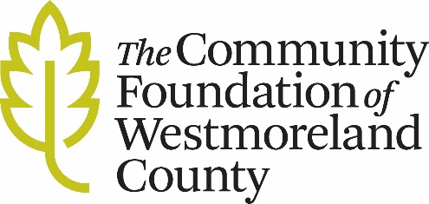

GFF GRANT FOLLOW-UP REPORT FORM

To: The Community Foundation of Westmoreland County

Due Date:

Grantee:
Organizational Contact:
Fund:
Purpose:
Approved Amount:
Grant#:

- Describe how grant funds received have been used in accordance with the above stated purpose and in conjunction with stated outcomes in your proposal.

- Are any grant funds unspent? If yes, please inform us of the amount and how and when the funds will be expended. If this grant is over $25,000, please give us a financial reporting of grant expenditures.

- List any changes in your organization that have occurred since you received the grant (leadership, grant contact, address, etc.)

Submitted by: ______ Date: _______________________.

Please send all follow-up forms to: Phil Koch
The Community Foundation of Westmoreland County
951 Old Salem Road
Greensburg, PA 15601
pkoch@cfwestmoreland.org

